BY MIRUDULA D
CSE AIML
RA2611026020038
1ST YEAR: BEGINNER CYBER SECURITY- TASK: 1

Room 1: What is Networking?
Room link: https://tryhackme.com/room/whatisnetworking

What I Did?
I completed all the tasks in this room, going through the material step by step and answering the questions as I went. The screenshot below shows all four tasks marked as complete on my TryHackMe dashboard.
TASK:1 WHAT IS NETWORKING?
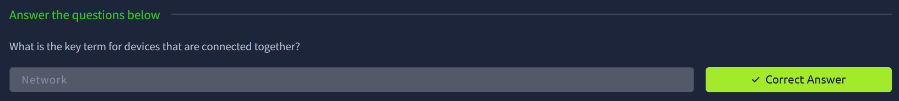
TASK:2 WHAT IS THE INTERNET?
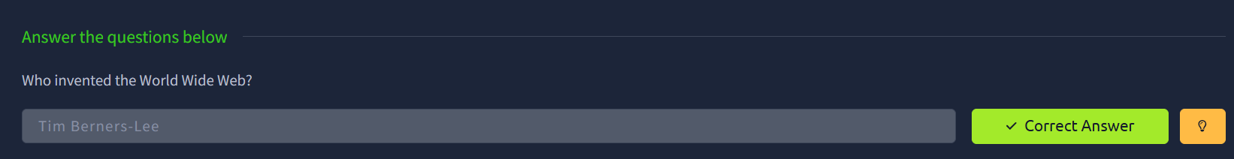
TASK:3 IDENTIFYING DEVICES ON A NETWORK
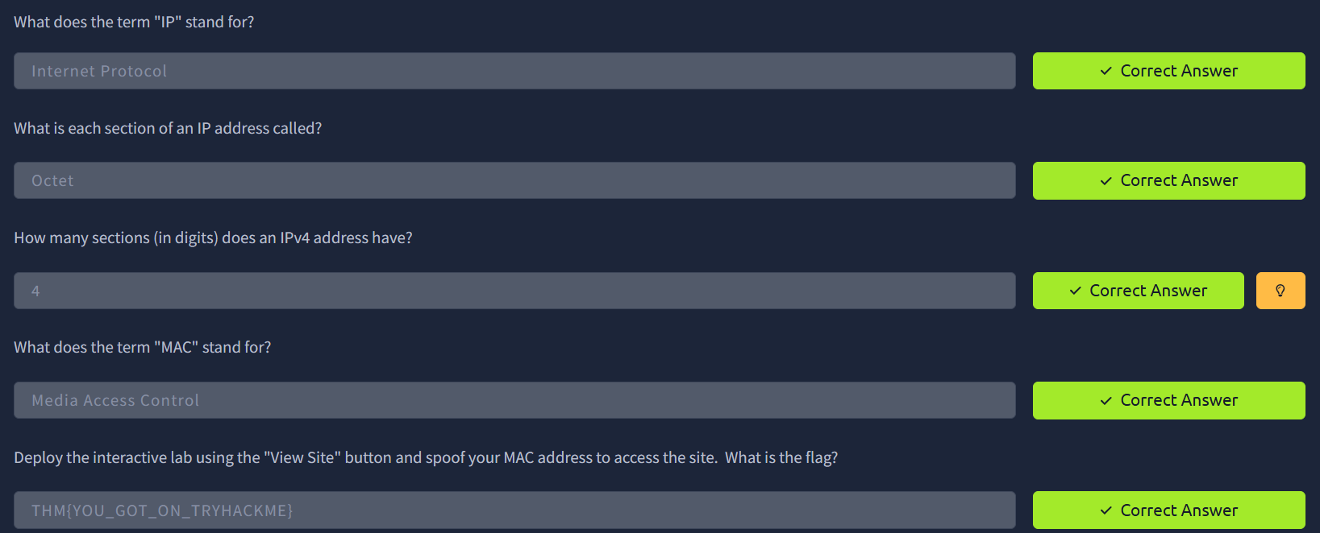

TASK:4 PING
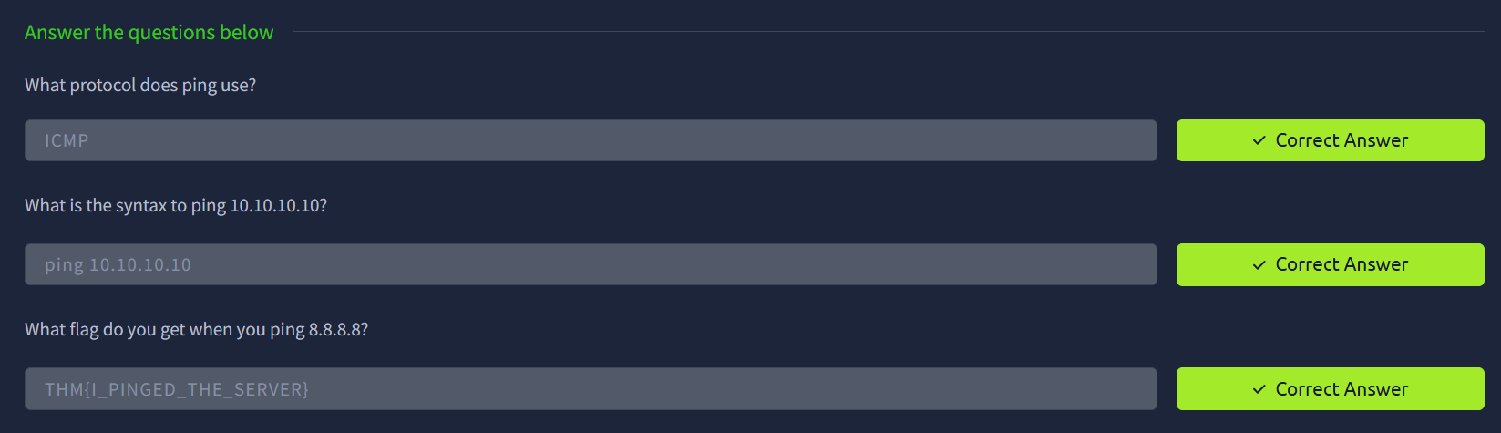
OVERALL, ROOM 1:
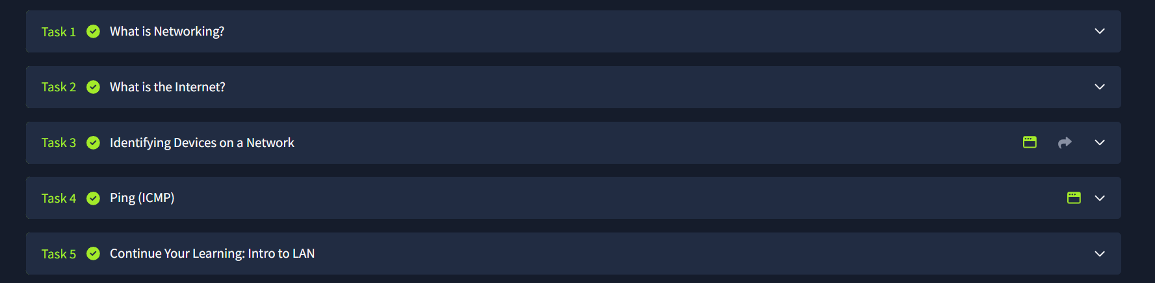

What I Learned?
Before this room, I honestly didn't know the difference between an IP address and a MAC address. I thought they were basically the same thing. Now I understand that an IP address is more like a temporary mailing address that can change depending on which network you're connected to, while a MAC address is permanently built into the device's hardware, like a serial number that never changes.
I also learned that "ping" isn't just a gaming term, it's an actual command you can type to test whether your computer can successfully talk to another device or website, using something called ICMP.
The MAC spoofing exercise was the part that made things click for me. Seeing how a device could pretend to be a different device on the network, just by changing one setting, showed me why network security has to think about more than just "is this the right password”, it also has to think about "is this actually the device it claims to be."
Overall, this room gave me the basic vocabulary that I needed before moving on to the next room, which went into more depth.
Room 2: Intro to Networking
ROOM LINK: https://tryhackme.com/room/introtonetworking

What I Did?
This room was longer and more detailed than the first one. It covered the OSI model, the TCP/IP model, encapsulation, and a set of practical command-line networking tools. Below is what I did for each part, with screenshots of my actual answers.
TASK 1. The OSI Model
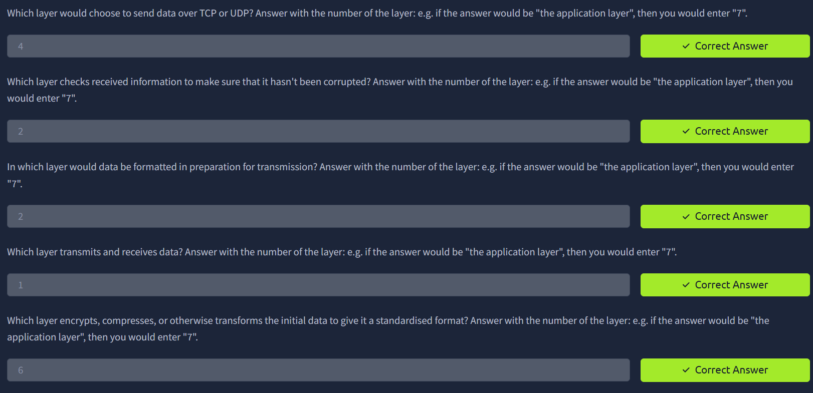
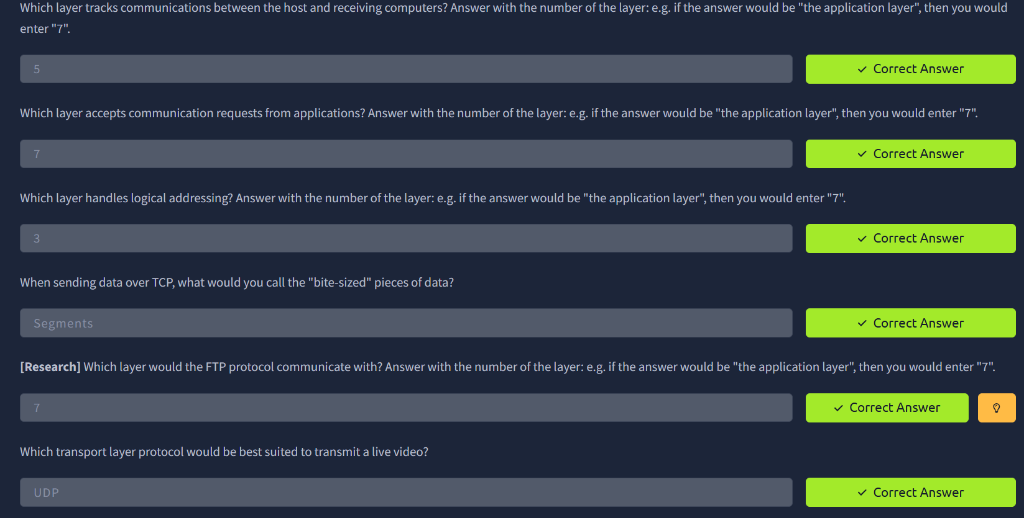

TASK 2. The TCP/IP Model and the Three-Way Handshake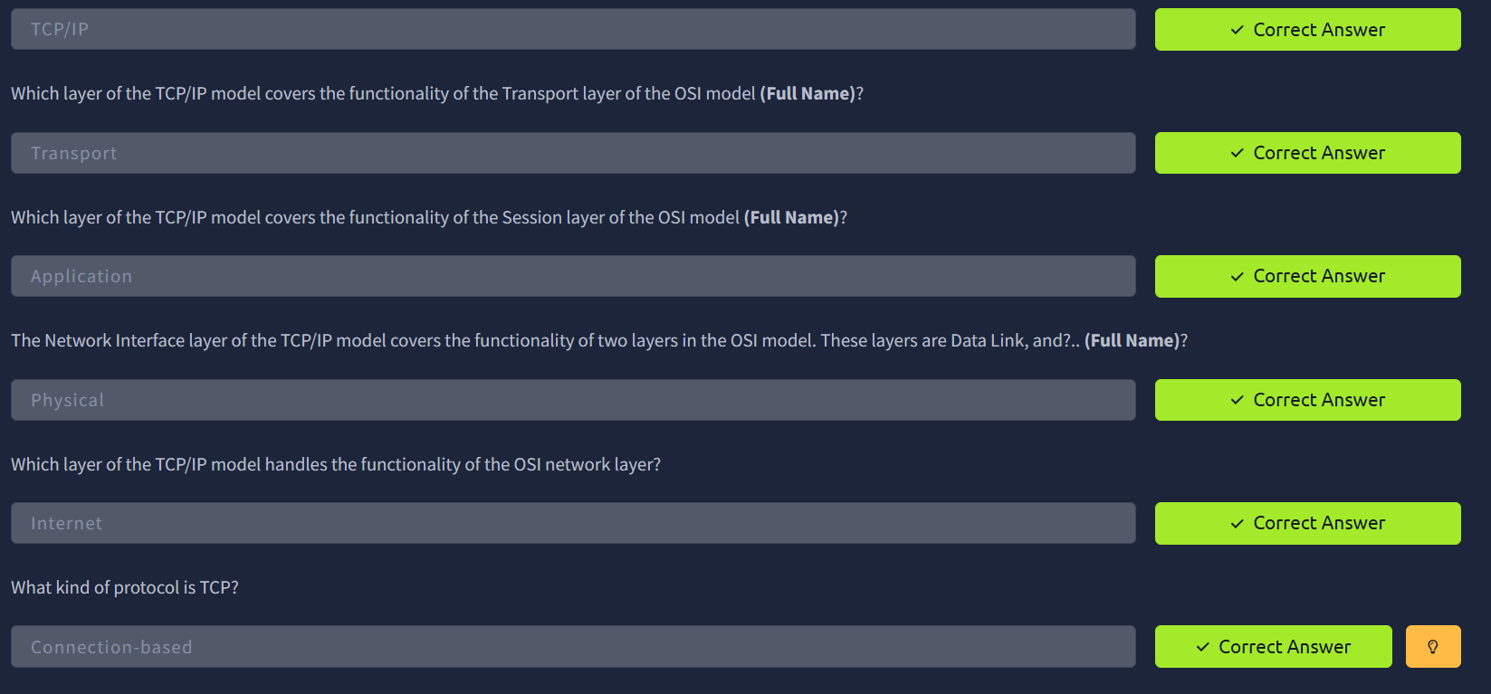
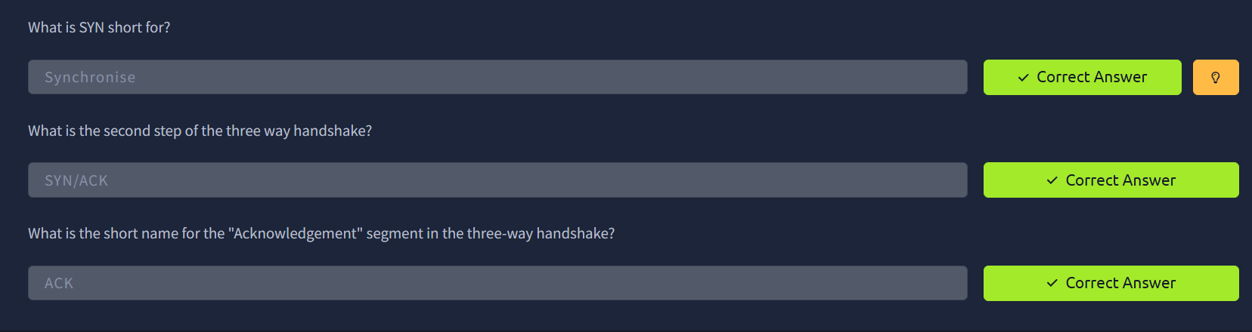
TASK 3. Encapsulation
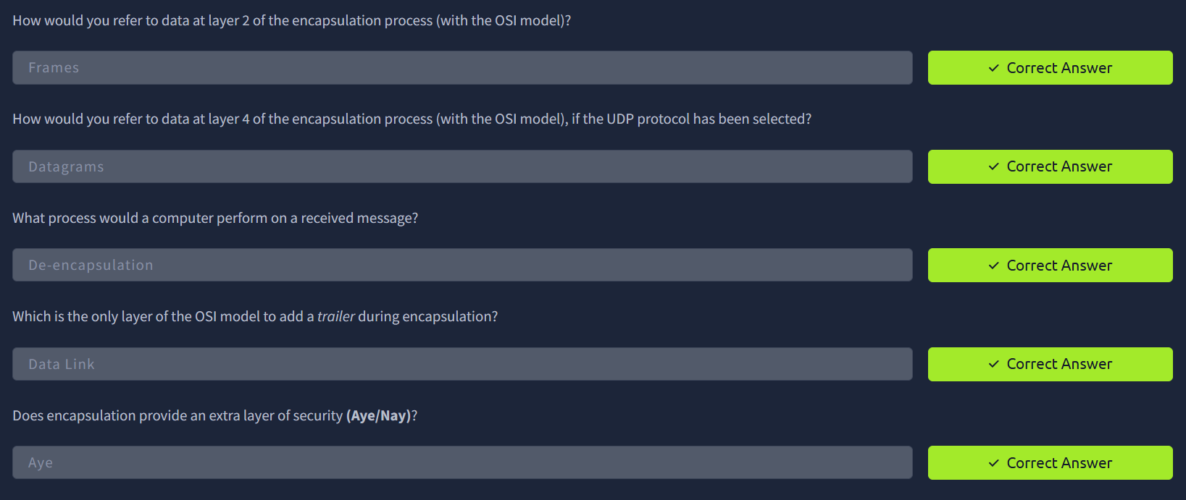

TASK 4. Traceroute
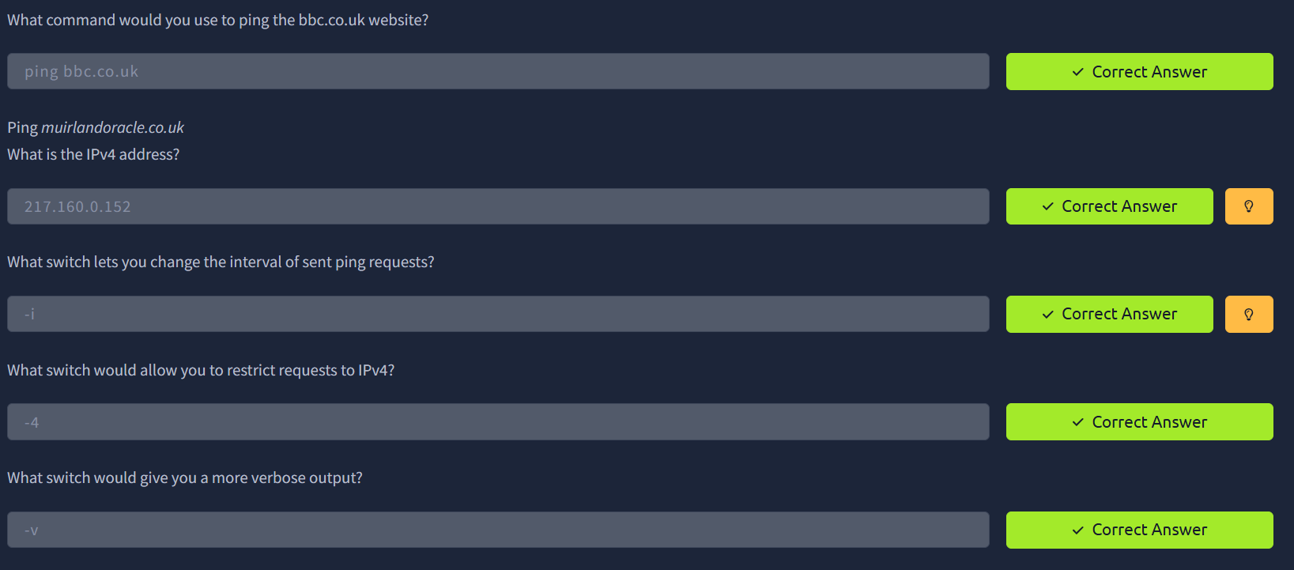
TASK 5. Ping
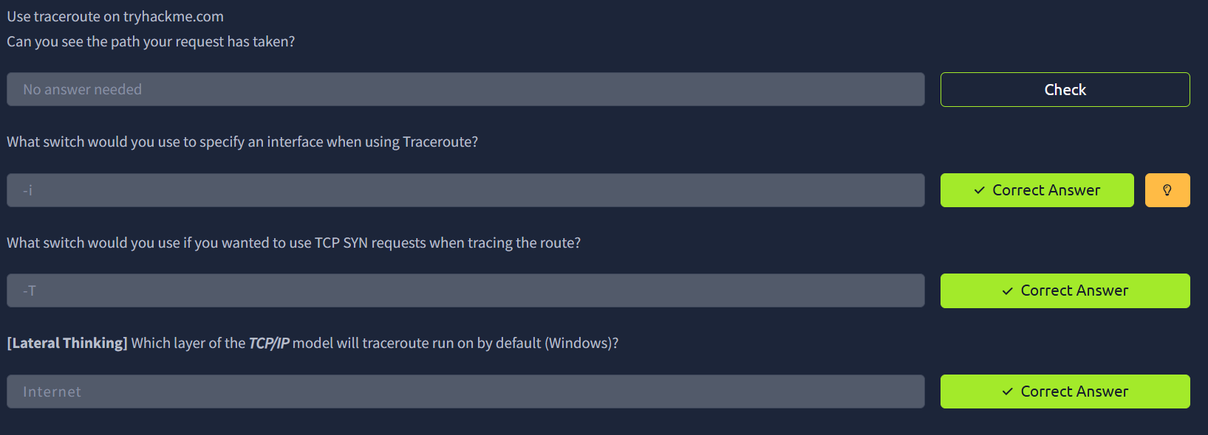
TASK 6. WHOIS Lookups
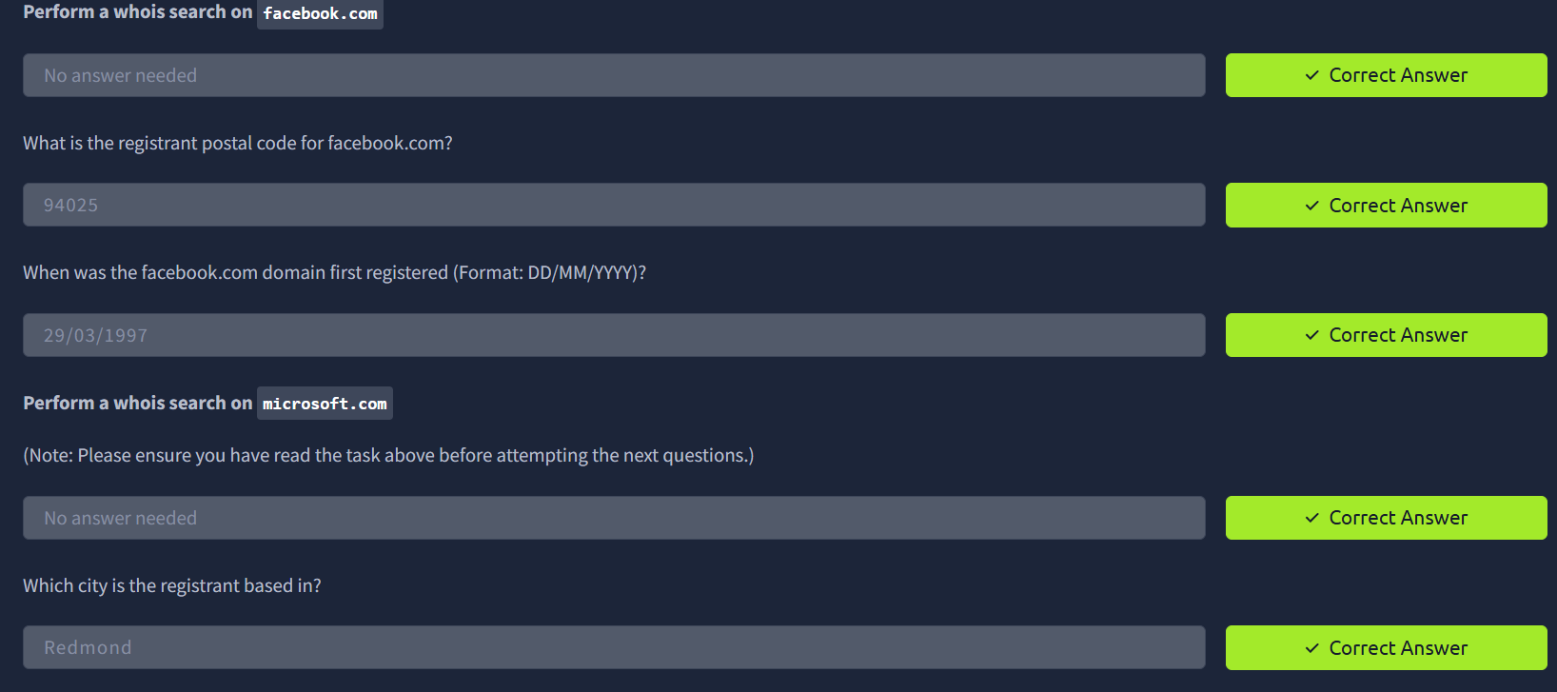

TASK 7. OSINT (Open-Source Intelligence)
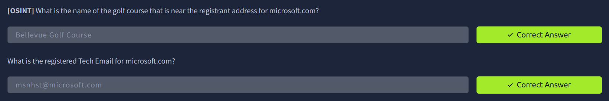
TASK 8. DNS
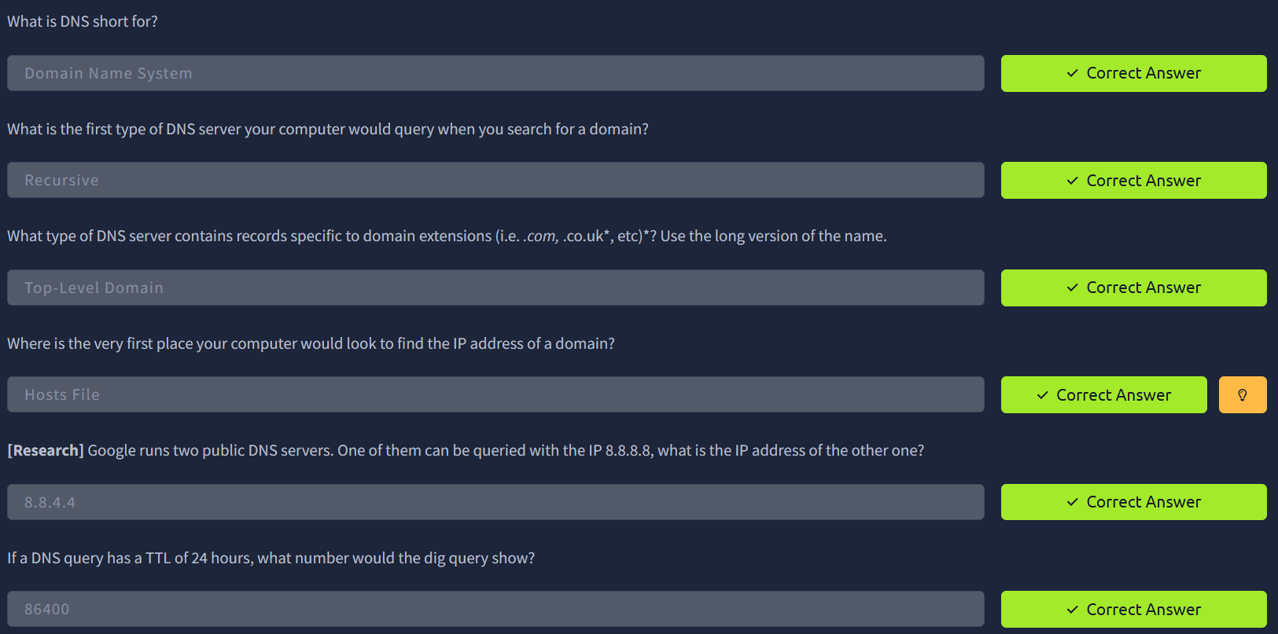
OVERALL, ROOM 2:
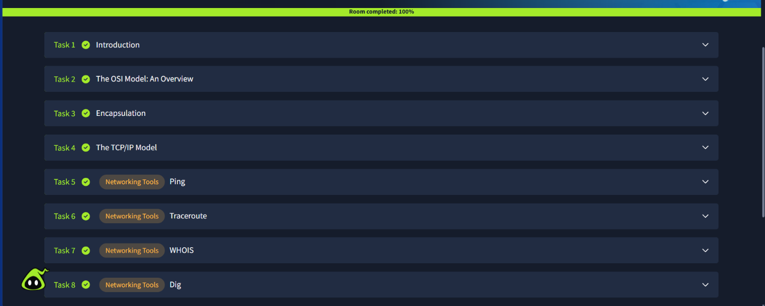

What I Learned?
This room connected a lot of dots for me. The biggest one was understanding that the OSI model and the TCP/IP model are describing the same journey data takes, just at different levels of detail, TCP/IP groups several OSI layers together into simpler categories. Before this, when I heard people mention "Layer 3" or "Layer 7," it meant nothing to me. Now I can place those numbers against real jobs, like Layer 3 handling IP addressing and Layer 7 being the application itself.
I also understood, for the first time, what happens when two computers set up a connection. The three-way handshake (SYN, then SYN/ACK, then ACK) is like a polite "can we talk?" / "yes, go ahead" / "okay, starting now" exchange before any real data gets sent. It made TCP feel a lot less abstract.
Encapsulation was a new concept for me to the idea that data gets wrapped in layer after layer of extra information as it's prepared for sending and then unwrapped in reverse order on the other end, the same way a letter goes into an envelope, then a mailbag, then a delivery truck, and gets unpacked step by step at the destination.
The practical tools were just as useful as the theory. I hadn't used traceroute or WHOIS before this room. Seeing traceroute show the hops my request took and seeing WHOIS pull up real registration details for big companies like Facebook and Microsoft, made the ideas feel real rather than just something in a textbook. The DNS section tied it all together. I now understand DNS as basically the internet's phonebook, translating names I type into the numeric address’s computers use to find each other.
Altogether, this room took the vocabulary I picked up in "What is Networking?" and turned it into a much clearer, practical picture of how data actually moves from one device to another across a network.

MY TRYHACKME link: TryHackMe | dmithu090309
Thank you!

